Evidence AUTOMATED APPOINTMENT REMINDER SYSTEM
Week 13 – Initial Project
Prepared by: April Joy S. Legaspi
Technology: Flutter and Dart
GitHub Repository:
https://github.com/its1aprilj/week13-appointment-reminder.git
1. INTRODUCTION
The Automated Appointment Reminder System is a software project designed to help users manage appointment information and monitor reminder processing. It provides an application interface for viewing appointments, checking their statuses, and performing available appointment-related actions.
This user manual provides step-by-step instructions on how to open, use, and test the application. It also explains the appointment statuses, basic troubleshooting procedures, and important safety practices.
Project Scope
The submitted GitHub repository contains the Flutter frontend of the system. The Laravel backend is maintained separately and must be running for features that communicate with the API to function.
Important Note: Reminder delivery during Week 13 testing is simulated. The system records simulated delivery results and does not claim that actual SMS or email messages were sent.Running the Application in Google Chrome
Execute the following command: flutter run -d chrome Wait for Flutter to build and launch the application in Google Chrome.
Application Running in Google Chrome
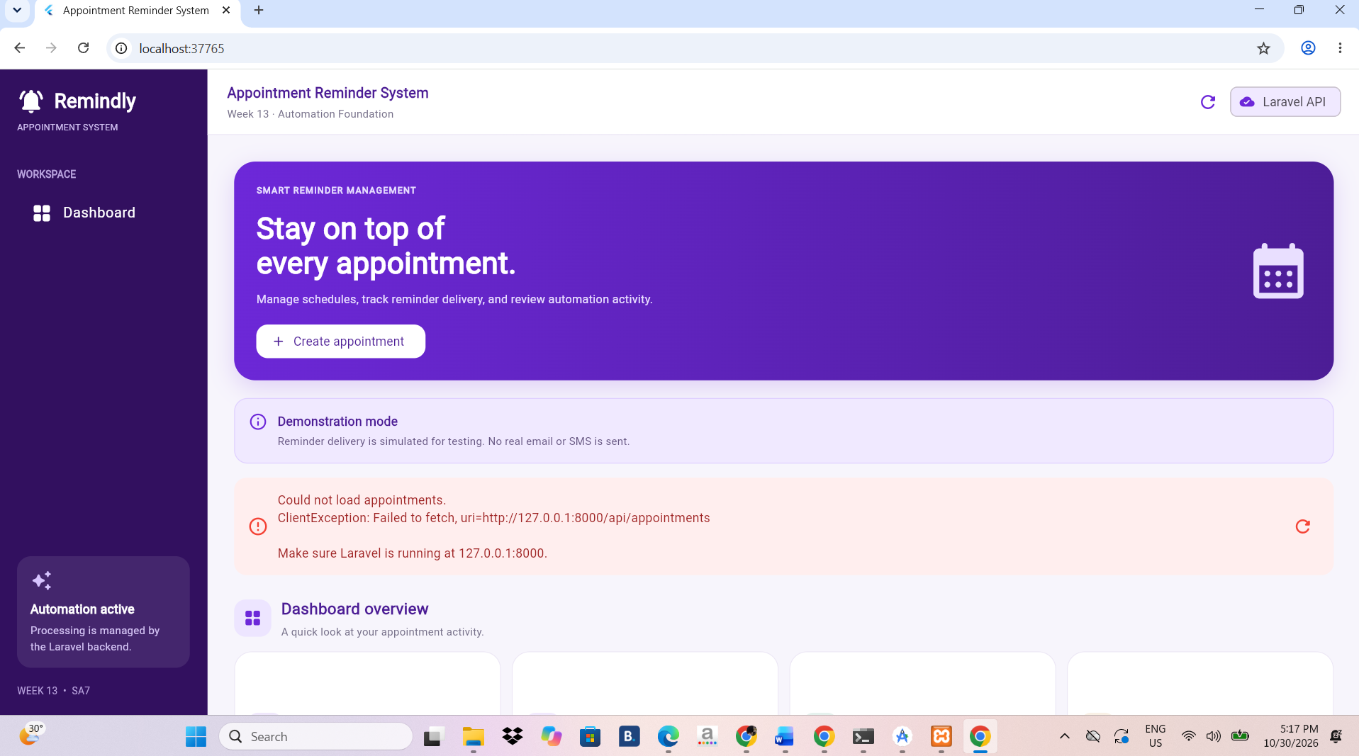

Figure 1. Automated Appointment Reminder System running in Google Chrome.

Viewing the Appointment Dashboard
The dashboard or appointment list allows users to view the appointment records available in the application..
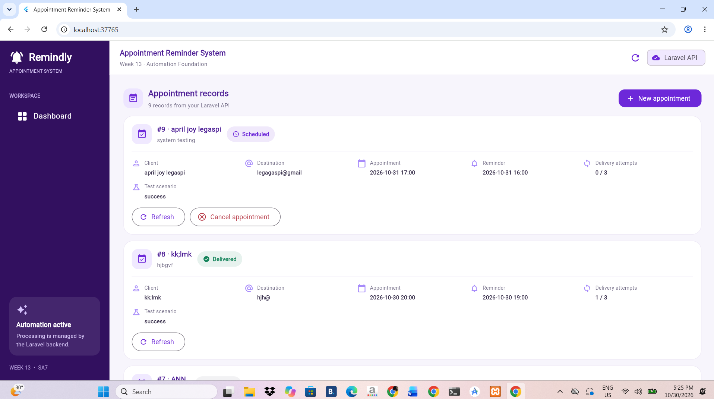

Figure 2. Appointment dashboard displaying available appointment records.

Creating an Appointment
This procedure applies if the current application build provides an appointment creation function.
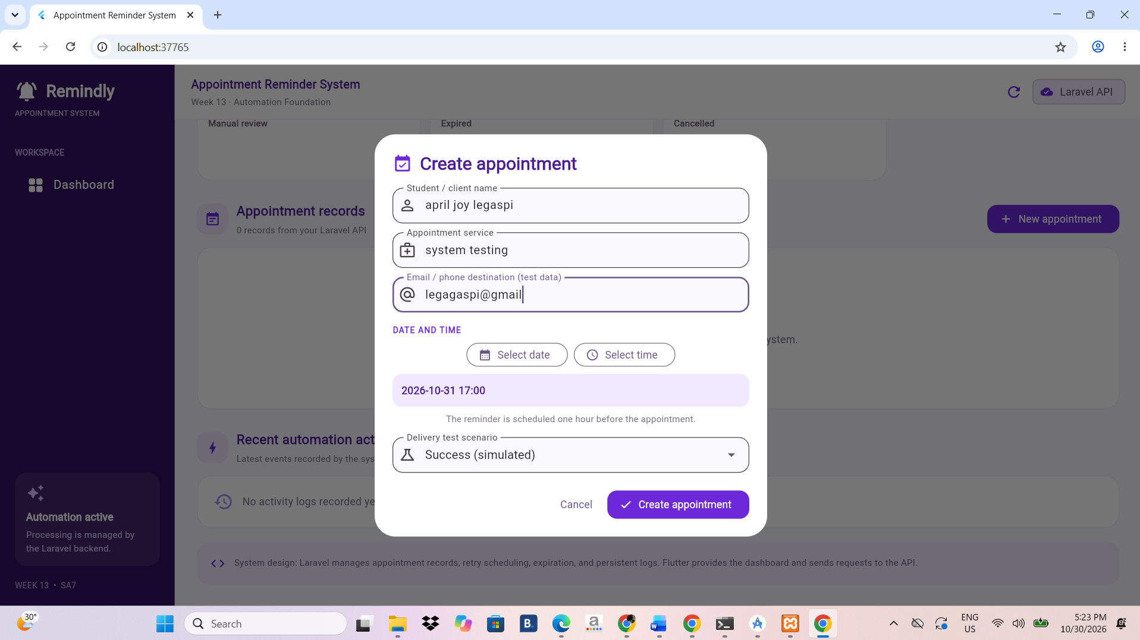

Figure 3. Appointment creation form.
Viewing Appointment Details
Users can inspect the information associated with an appointment.Appointment Details
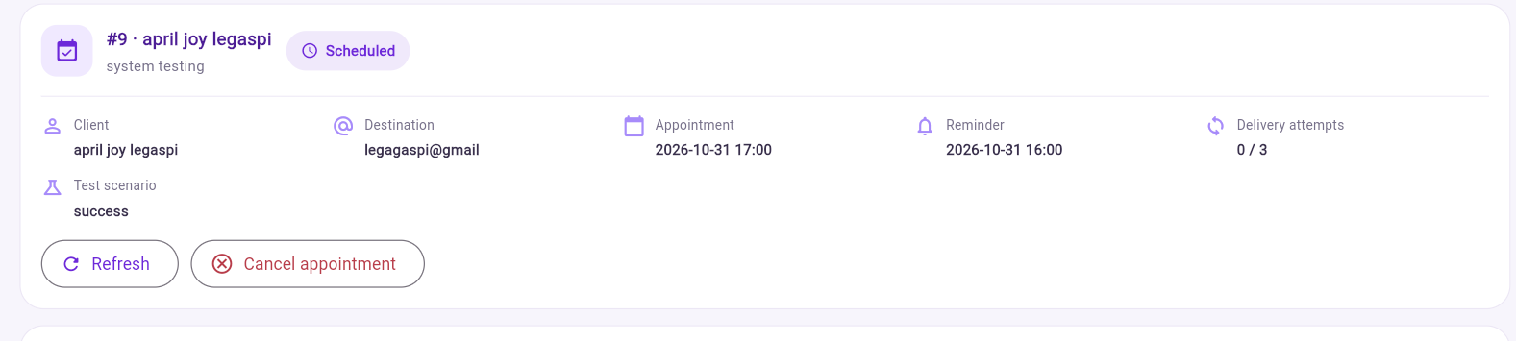

Figure 4. Appointment information and status

Cancelling an Appointment
This procedure applies if the application provides an appointment cancellation option.
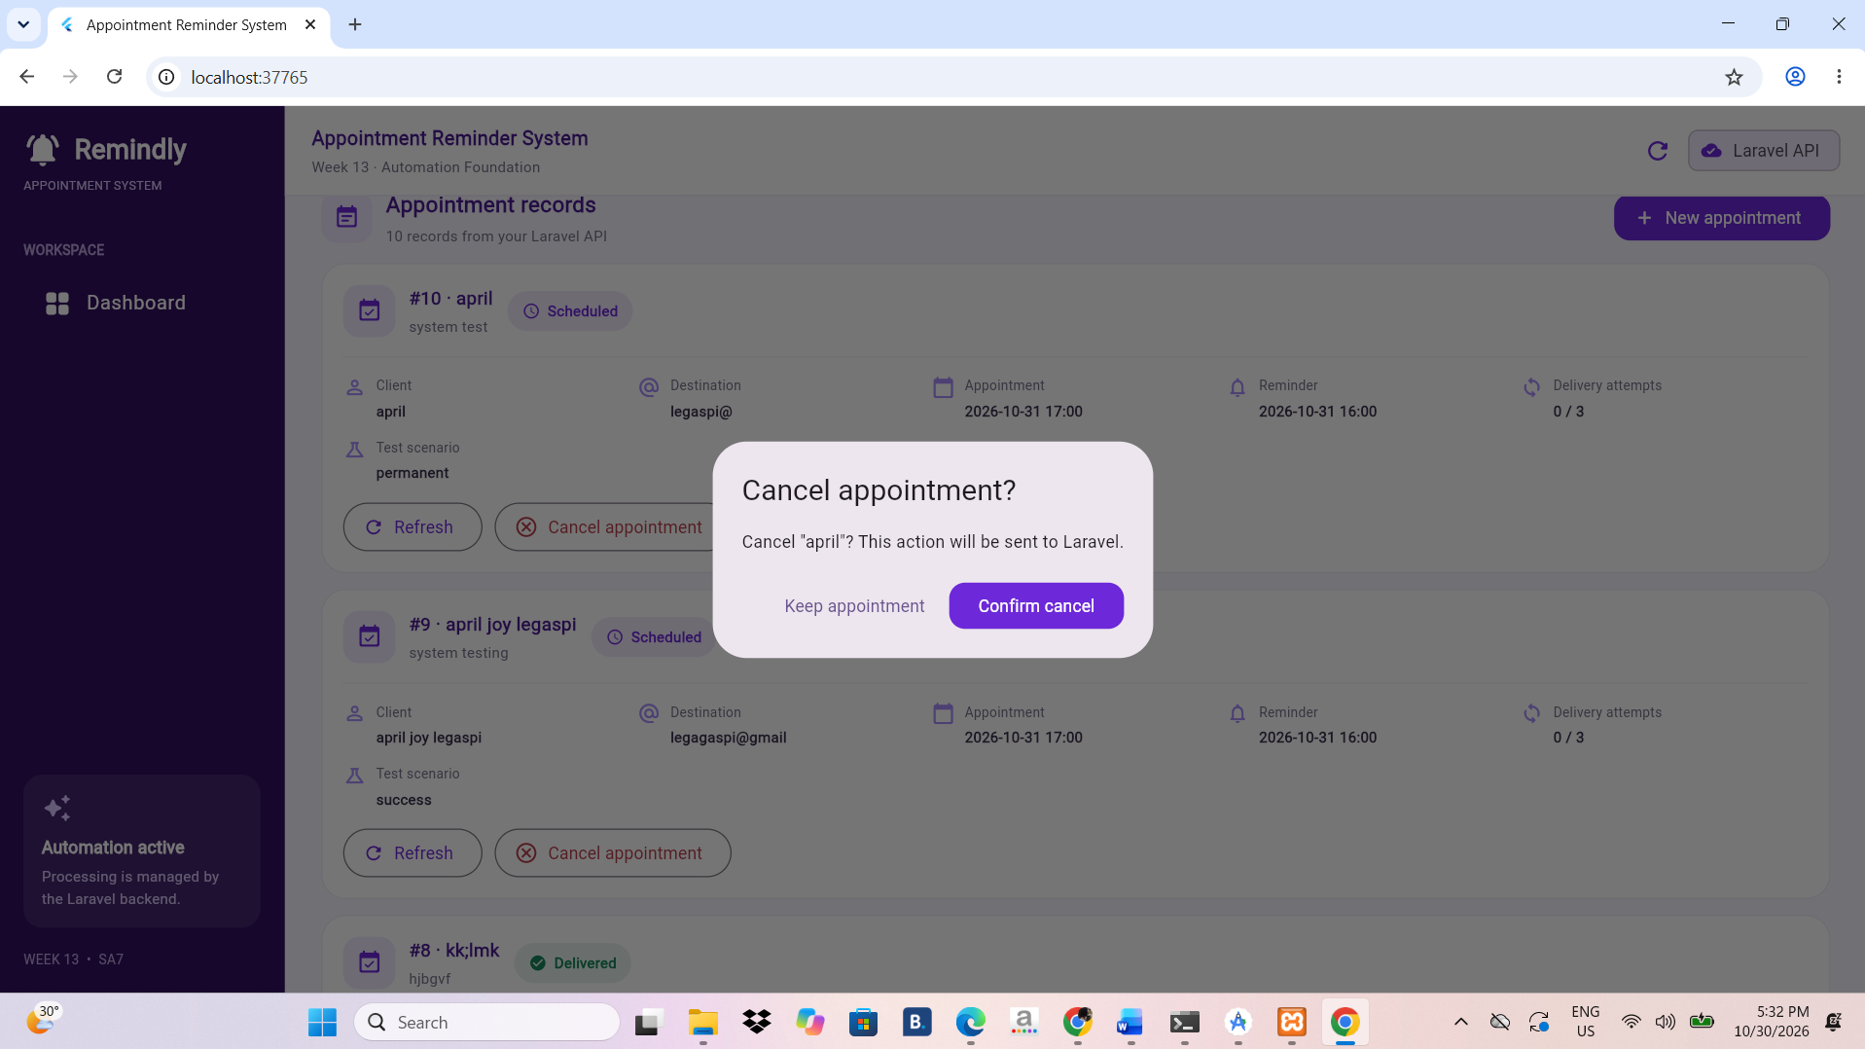

Figure 6. Appointment cancellation or cancelled appointment status.

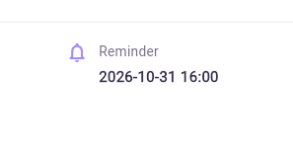
Reminder status or reminder logs

Expired appointment test result, if visible
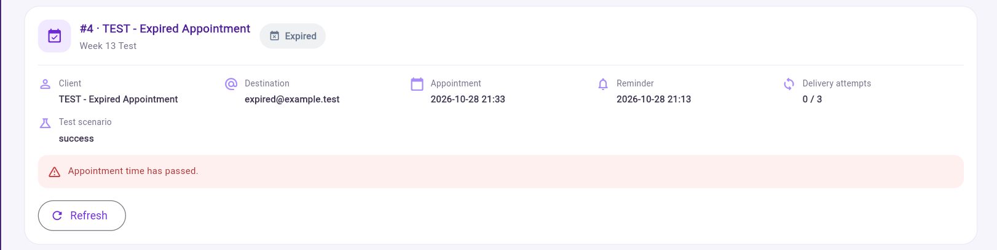

5. APPOINTMENT AND REMINDER STATUS GUIDE
The following statuses are used in the Week 13 project tests:
Scheduled
The appointment or reminder is scheduled for processing.
Retrying
A temporary simulated delivery problem occurred, and another attempt has been scheduled.
Delivered
The system recorded a successful simulated reminder delivery. This does not mean that an actual SMS or email was sent.
Manual Review
The system requires further inspection or action because the reminder encountered a problem that cannot be handled through automatic retries.
Cancelled
The appointment was cancelled, and pending reminders should no longer be processed.
Expired
The appointment time has passed, and the reminder is no longer eligible for normal processing.

6. SAFETY, PRIVACY, AND DATA INTEGRITY
The following practices must be observed when using and testing the system:
- Use sample appointment records during demonstrations.
- Do not enter unnecessary confidential or sensitive personal information.
- Never upload database passwords, API keys, access tokens, or .env files to GitHub.
- Verify appointment details before saving, rescheduling, or cancelling.
- Do not modify database records without authorization.
- Use only authorized access to the application and backend.
- Keep screenshots accurate and ensure they represent actual application results.
- Clearly identify simulated reminder delivery in demonstrations and documentation

TROUBLESHOOTING
Problem: The application does not start.
Solution:
- Check whether Flutter is installed.
- Open the correct project folder.
- Run flutter pub get.
- Run flutter run -d chrome again.
Problem: Google Chrome is not detected.
Solution:
- Make sure Google Chrome is installed.
- Execute:
flutter devices

